**Neuromorphic Multisensory Numerosity Perception Enhanced by a Tactile Glove**

Hongwei Tan1,2, Syed Ashraf 1, Sebastian Hannula1, Zhong-Peng Lv1, Bo Peng1,3, Sebastiaan van Dijken1

1Department of Applied Physics, Aalto University, 02150 Espoo, Finland

2Max Planck Institute for Polymer Research, 55128 Mainz, Germany

3Department of Materials Science and State Key Laboratory of Molecular Engineering of Polymers, Fudan University, 200433, Shanghai, China

**Abstract**

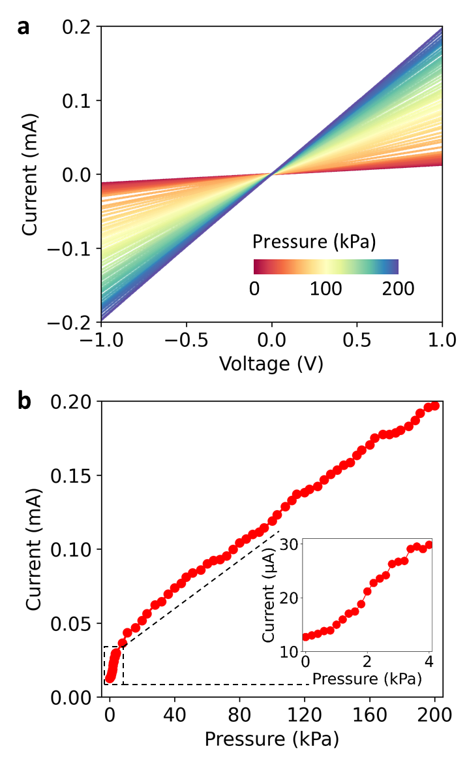Neuromorphic numerosity perception utilizes bioinspired sensory systems to process and interpret numerical information, mimicking how the human brain perceives quantity. Here, we present a tactile glove with gesture-learning capability to enhance neuromorphic numerosity perception, generated by vision or auditory inputs. Equipped with 10 flexible pressure sensors strategically positioned on finger joints, the glove accurately recognizes hand gestures representing numbers. By integrating these tactile signals with visual and auditory cues through multisensory integration, the system significantly improves numerosity perception.

*Keywords*: pressure sensor, gesture recognition, multisensory integration, neuromorphic numerosity perception

**Introduction**

Numerosity perception, the intuitive ability to estimate and process numerical quantities, is a fundamental cognitive function of the human brain [1-2]. Mimicking this ability through bioinspired sensory systems holds potential for applications in robotics, human-computer interaction, and assistive technologies. Recent advancements in neuromorphic systems with multisensory integration [3-10] have demonstrated the potential to emulate the brain's capability to integrate information across modalities such as vision, touch, and sound [11-13]. These multisensory systems enable applications like accurate object recognition, navigation, and decision-making.

In this study, we present a neuromorphic tactile glove designed to enhance numerosity perception through bioinspired multisensory integration. The glove is equipped with 10 distributed pressure sensors placed on the finger joints to detect bending movements, enabling gesture recognition and learning. With the aid of an artificial neural network, the system achieves efficient recognition of number expressed through American Sign Language. Our results demonstrate the systems’ capability to improve numerosity perception accuracy to 96.3%, significantly outperforming unisensory accuracies: 36.4% for vision, 83.2% for touch, and 68.9% for audio. This highlights the benefits of multisensory integration in achieving superior performance. The proposed tactile glove system has promising applications in self-learning robotics, industrial manufacturing, social robotics, and intuitive human-machine interactions.

Fig. 1: Pressure sensor performance characterization. a, Current-voltage (I-V) characteristics of the pressure sensor measured under applied pressures ranging from 0 to 200 kPa. b, Current output values of the pressure sensor at a fixed voltage of 1 V, derived from the data in (a).

**Results**

*Pressure sensor*

A two dimensional (2D) MXene-based freestanding film, optimized based our previous work [14-16], was used as the pressure-sensitive medium. This MXene film was placed on a cross-finger-structured Au/Ti electrode deposited on flexible PET substrates. The electrodes were fabricated via magnetron sputtering using a shadow mask. The working area of the pressure sensor is 5 mm × 5 mm. The pressure sensor operates effectively within a range of 0 to 200 kPa (Figure 1), encompassing the working range of biological mechanoreceptors. Moreover, the sensor demonstrates high sensitivity to low pressures (0-4 kPa, inset of Figure 1b), highlighting its wide working range and suitability for tactile applications.

*Tactile glove for gesture recognition*

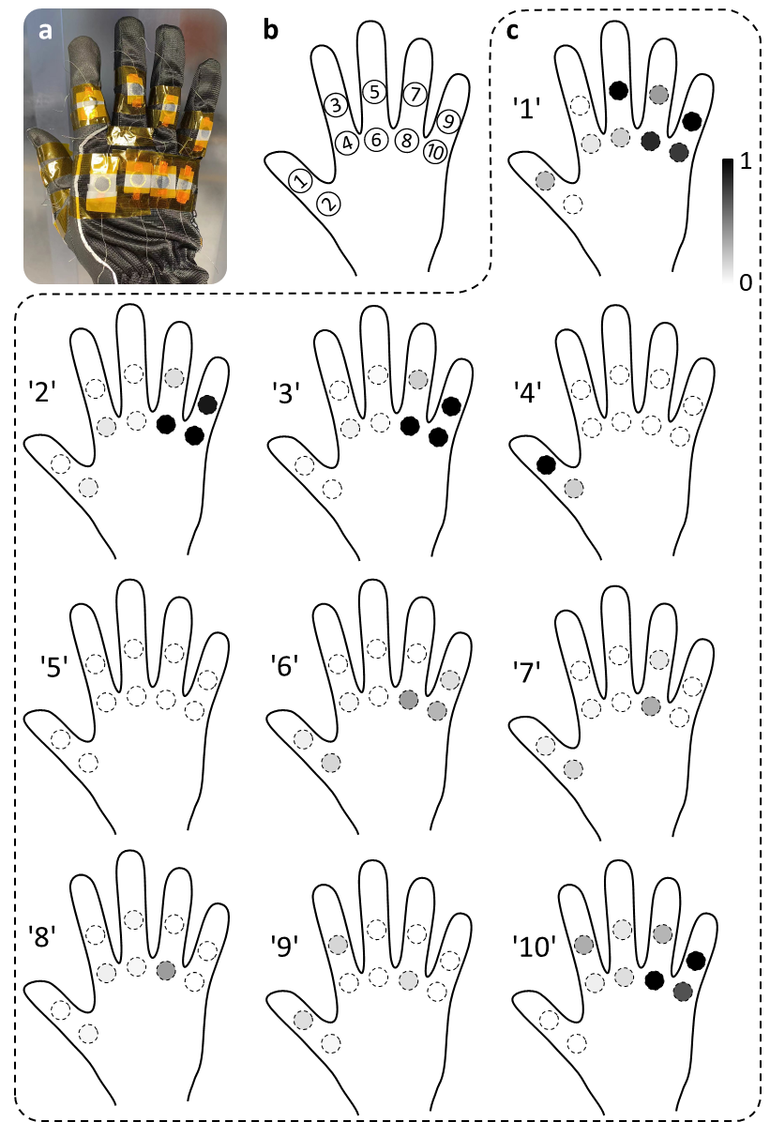Ten pressure sensors were positioned on the joint areas of a glove to enable gesture detection. The normalized response of these sensors is shown in Figure 2 for American Sign Language numbers 1 to 10.

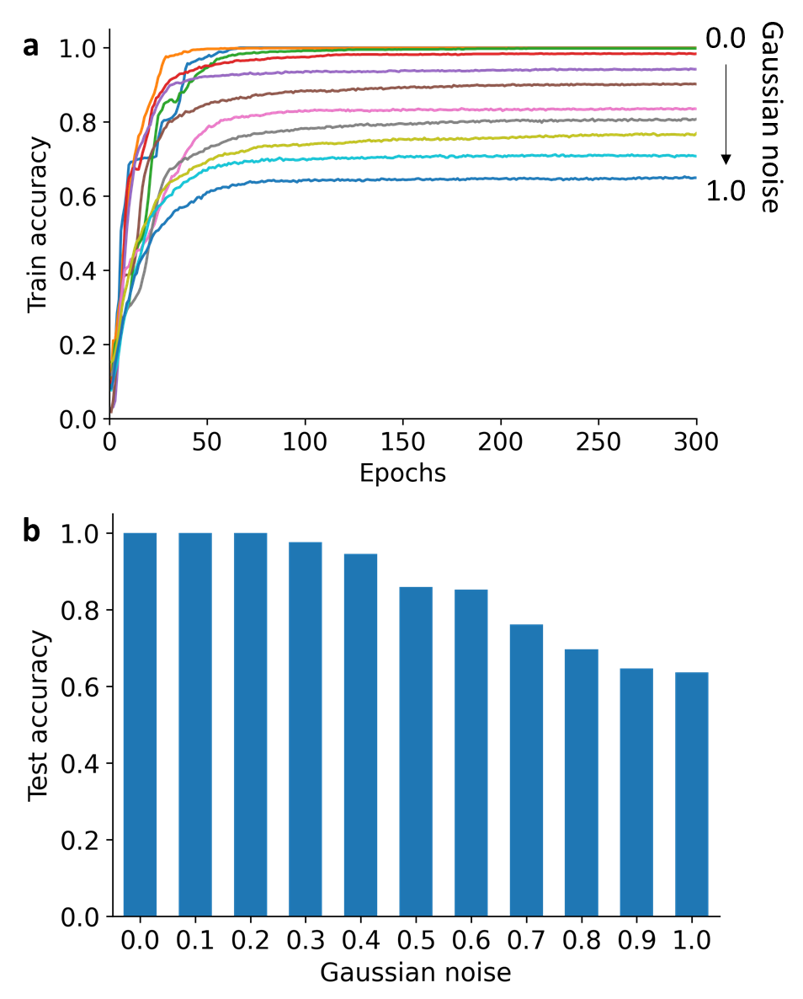Fig. 2: Tactile glove with MXene-based pressure sensors positioned on joint areas. a, Photograph of the tactile glove. b, Schematic illustration of sensor positions distributed across the tactile glove. c, Tactile response patterns corresponding to gestures representing American Sign Language numbers 1 to 10.

Fig. 3: Training and testing performance of the system for recognizing American Sign Language numbers 1 to 10. a, Training accuracy across 300 epochs with Gaussian noise levels ranging from 0% to 100% added to tactile datasets. b, Test accuracies of the ANN trained on tactile datasets with varying levels of Gaussian noise.

A simple artificial neural network (ANN) was employed to classify the tactile patterns corresponding to these numbers. The ANN comprises 10 inputs neurons (representing the 10 tactile sensors), 15 hidden neurons, and 10 output neurons (corresponding to the 10 numbers). A dataset of 2000 samples was used for training, augmented with Gaussian noise to enhance system robustness. After 300 training epochs, the system achieved 100% accuracy with <20% Gaussian noise and ~64% accuracy even with 100% Gaussian noise. These results demonstrate the robust gesture recognition capability of the tactile glove.

*Tactile-enhanced multisensory numerosity perception*

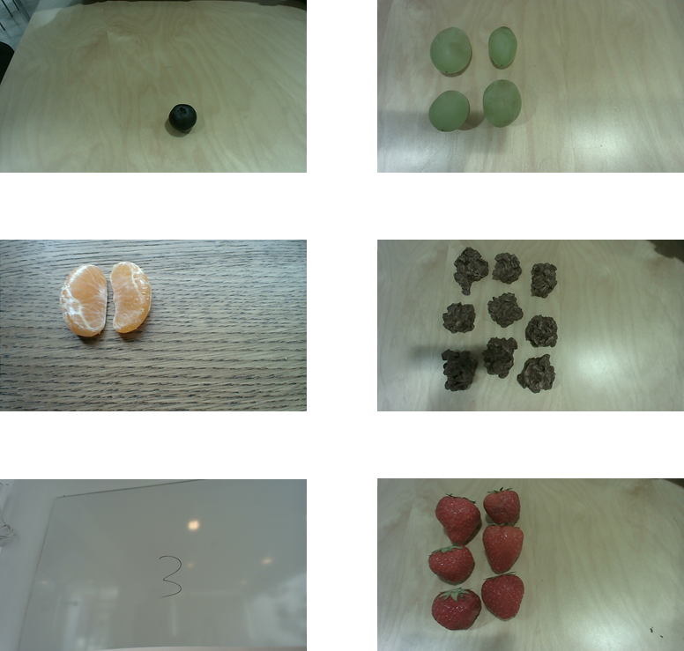To improve numerosity perception under unisensory visual or auditory inputs, we mimicked biological multisensory integration principles [11-13] by incorporating tactile information. For example, unisensory vision-based numerosity perception yielded a low accuracy of 36.4%, tested through object quantity recognition using real image datasets (Figure 4). Similarly, unisensory audio-based numerosity perception achieved an accuracy of 68.9%.

Fig. 4: Representative visual image datasets used for testing visual numerosity perception.

To improve performance, we integrated tactile, visual, and auditory data into a combined database of 2000 samples per quantity (1 to 10). An ANN with identical hidden and output layers was trained using this multimodal dataset. After 300 training epochs, the system achieved an accuracy of 99%, significantly outperforming unisensory results: 53% for vision, 91% for touch, and 78% for audio (Figure 5). The test accuracy was also markedly higher at 96.3%, compared to 36.4% (vision), 83.2% (touch), and 68.9% (audio) for unisensory perception (Figure 6).

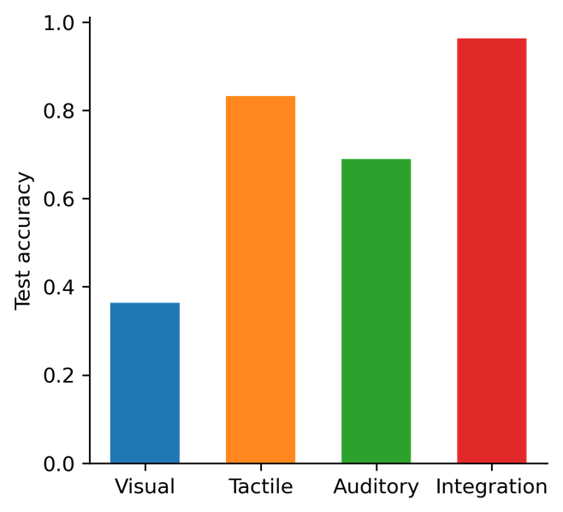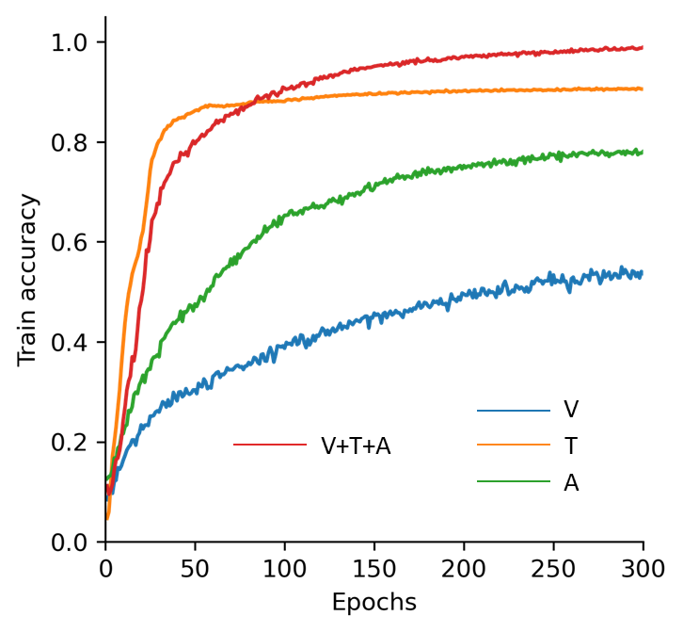Fig. 5: Training accuracies for numerosity perception using unisensory inputs - visual (V), tactile (T), auditory (A) - and multisensory integration (V+T+A).

Fig. 6: Test accuracies for numerosity perception with unisensory inputs and multisensory integration.

**Conclusion**

We developed a neuromorphic tactile glove with MXene-based pressure sensors for accurate recognition of American Sign Language numbers. By integrating tactile, visual, and auditory inputs, we emulated cortical multisensory integration to achieve superior neuromorphic multisensory numerosity perceptions. This tactile-enhanced system significantly exceeds unisensory performance in recognition accuracy and demonstrates potential for applications in cross-modal self-learning, industrial manufacturing, social robotics, and intuitive human-machine interaction. Additionally, the tactile glove offers promising opportunities for advancing neuromorphic vision [17] and other sensory technologies.

**Acknowledgments**

We gratefully acknowledge E.I. Kauppinen for providing infrastructure support for the electrical measurements. The project made use of the OtaNano—Micronova Nanofabrication Center and the OtaNano—Nanomicroscopy Center, supported by Aalto University. This work was supported by the Research Council of Finland (Grant no. 316973 H. T.).

**References**

1. W. S. Jevgns, “The Power of Numerical Discrimination”, Nature, 3, pp. 281-282 (1871).
2. S. J. Cheyette, and S. T. Piantadosi, “A unified account of numerosity perception”, Nat. Hum. Behav., 4, pp. 1265–1272 (2020).
3. N. Fazeli, M. Oller, J. Wu, Z. Wu, J. B. Tenenbaum, and A. Rodriguez, “See, feel, act: Hierarchical learning for complex manipulation skills with multisensory fusion”, Sci. Robot., 4, pp. eaav3123 (2019).
4. C. Wan, P. Cai, X. Guo, M. Wang, N. Matsuhisa, L. Yang, Z. Lv, Y. Luo, X. J. Loh, and X. Chen, “An artificial sensory neuron with visual-haptic fusion”, Nat. Commun., 11, pp. 4602 (2020).
5. M. Wang, Z. Yan, T. Wang, P. Cai, S. Gao, Y. Zeng, C. Wan, H. Wang, L. Pan, J. Yu, S. Pan, K. He, J. Lu, and X. Chen, “Gesture recognition using a bioinspired learning architecture that integrates visual data with somatosensory data from stretchable sensors”, Nat. Electron., 3, pp. 563–570 (2020).
6. H. Tan, Y. Zhou, Q. Tao, J. Rosen, and S. van Dijken, “Bioinspired multisensory neural network with crossmodal integration and recognition”, Nat. Commun., 12, pp. 1120 (2021).
7. J. Yu, Y. Wang, S. Qin, G. Gao, C. Xu, Z. L. Wang, and Q. Sun, “Bioinspired interactive neuromorphic devices”, Mater. Today, 60, pp. 158-182 (2022).
8. F. Yu, Y. Wu, S. Ma, M. Xu, H. Li, H. Qu, C. Song, T. Wang, R. Zhao, and L. Shi, “Brain-inspired multimodal hybrid neural network for robot place recognition”, Sci. Robot., 8, pp. eabm6996 (2023).
9. X. Liu, C. Sun, X. Ye, X. Zhu, C. Hu, H. Tan, S. He, M. Shao, and R.-W. Li, “Neuromorphic Nanoionics for Human–Machine Interaction: From Materials to Applications”, Adv. Mater., 36, pp. 2311472 (2024).
10. Q. Mao, Z. Liao, J. Yuan, and R. Zhu, “Multimodal tactile sensing fused with vision for dexterous robotic housekeeping”, Nat. Commun., 15, pp. 6871 (2024).
11. B. E. Stein, and M. A. Meredith, “Multisensory Integration”, Science, 261, pp. 928-929 (1993).
12. J. J. McDonald, W. A. Teder-Sälejärvi, and L. M. Ward, “Multisensory Integration and Crossmodal Attention Effects in the Human Brain”, Science, 292, pp. 1791 (2001).
13. Z. Okray, P. F. Jacob, C. Stern, K. Desmond, N.Otto, C. B. Talbot, P. Vargas-Gutierrez, and S. Waddell, “Multisensory learning binds neurons into a cross-modal memory engram”, Nature, 617, pp. 777-784 (2023).
14. H. Tan, Q. Tao, I. Pande, S. Majumdar, F. Liu, Y. Zhou, P. O.Å. Persson, J. Rosen, and S. van Dijken, “Tactile sensory coding and learning with bio-inspired optoelectronic spiking afferent nerves”, Nat. Commun., 11, pp. 1369 (2020).
15. H. Tan, and S. van Dijken, “Dynamic machine vision with retinomorphic photomemristor-reservoir computing”, Nat. Commun., 14, pp. 2169 (2023).
16. X. Hong, Z. Xu, Z.-P. Lv, Z. Lin, M. Ahmadi, L. Cui, V. Liljeström, V. Dudko, J. Sheng, X. Cui, A. P Tsapenko, J. Breu, Z.Sun, Q. Zhang, E. Kauppinen, B. Peng, and Olli Ikkala. “High‐permittivity Solvents Increase MXene Stability and Stacking Order Enabling Ultraefficient Terahertz Shielding”, Adv. Sci. 11, pp. 2305099 (2024).
17. H. Tan, and S. van Dijken, “A universal neuromorphic vision processing system”, Nat. Electron., https://doi.org/10.1038/s41928-024-01288-9 (2024)